MySQL -Day 2

Entity Relationship Diagram

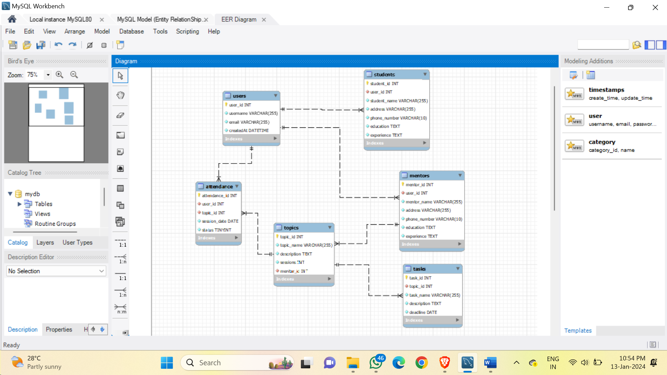

Code : Forward Engineer

-- MySQL Workbench Forward Engineering

SET @OLD_UNIQUE_CHECKS=@@UNIQUE_CHECKS, UNIQUE_CHECKS=0;

SET @OLD_FOREIGN_KEY_CHECKS=@@FOREIGN_KEY_CHECKS, FOREIGN_KEY_CHECKS=0;

SET @OLD_SQL_MODE=@@SQL_MODE, SQL_MODE='ONLY_FULL_GROUP_BY,STRICT_TRANS_TABLES,NO_ZERO_IN_DATE,NO_ZERO_DATE,ERROR_FOR_DIVISION_BY_ZERO,NO_ENGINE_SUBSTITUTION';

-- -----------------------------------------------------

-- Schema mydb

-- -----------------------------------------------------

-- -----------------------------------------------------

-- Schema mydb

-- -----------------------------------------------------

CREATE SCHEMA IF NOT EXISTS `mydb` DEFAULT CHARACTER SET utf8 ;

-- -----------------------------------------------------

-- Schema zenclass

-- -----------------------------------------------------

USE `mydb` ;

-- -----------------------------------------------------

-- Table `mydb`.`users`

-- -----------------------------------------------------

CREATE TABLE IF NOT EXISTS `mydb`.`users` (

`user_id` INT NOT NULL AUTO_INCREMENT,

`username` VARCHAR(255) NOT NULL,

`email` VARCHAR(255) NOT NULL,

`createdAt` DATETIME NOT NULL DEFAULT now(),

PRIMARY KEY (`user_id`),

UNIQUE INDEX `user_id_UNIQUE` (`user_id` ASC) )

ENGINE = InnoDB;

-- -----------------------------------------------------

-- Table `mydb`.`students`

-- -----------------------------------------------------

CREATE TABLE IF NOT EXISTS `mydb`.`students` (

`student_id` INT NOT NULL AUTO_INCREMENT,

`user_id` INT NOT NULL,

`student_name` VARCHAR(255) NOT NULL,

`address` VARCHAR(255) NOT NULL,

`phone_number` VARCHAR(10) NOT NULL,

`education` TEXT NOT NULL,

`experience` TEXT NOT NULL,

PRIMARY KEY (`student_id`),

UNIQUE INDEX `student_id_UNIQUE` (`student_id` ASC) VISIBLE,

INDEX `user_id_idx` (`user_id` ASC) VISIBLE,

CONSTRAINT `user_id`

FOREIGN KEY (`user_id`)

REFERENCES `mydb`.`users` (`user_id`)

ON DELETE NO ACTION

ON UPDATE NO ACTION)

ENGINE = InnoDB;

-- -----------------------------------------------------

-- Table `mydb`.`mentors`

-- -----------------------------------------------------

CREATE TABLE IF NOT EXISTS `mydb`.`mentors` (

`mentor_id` INT NOT NULL AUTO_INCREMENT,

`user_id` INT NOT NULL,

`mentor_name` VARCHAR(255) NOT NULL,

`address` VARCHAR(255) NOT NULL,

`phone_number` VARCHAR(10) NOT NULL,

`education` TEXT NOT NULL,

`experience` TEXT NOT NULL,

PRIMARY KEY (`mentor_id`),

UNIQUE INDEX `mentor_id_UNIQUE` (`mentor_id` ASC) ,

INDEX `user_id_idx` (`user_id` ASC) ,

CONSTRAINT `user_id`

FOREIGN KEY (`user_id`)

REFERENCES `mydb`.`users` (`user_id`)

ON DELETE NO ACTION

ON UPDATE NO ACTION)

ENGINE = InnoDB;

-- -----------------------------------------------------

-- Table `mydb`.`topics`

-- -----------------------------------------------------

CREATE TABLE IF NOT EXISTS `mydb`.`topics` (

`topic_id` INT NOT NULL AUTO_INCREMENT,

`topic_name` VARCHAR(255) NOT NULL,

`description` TEXT NOT NULL,

`sessions` INT NOT NULL,

`mentor_id` INT NOT NULL,

PRIMARY KEY (`topic_id`),

UNIQUE INDEX `topic_id_UNIQUE` (`topic_id` ASC) ,

INDEX `mentor_id_idx` (`mentor_id` ASC) ,

CONSTRAINT `mentor_id`

FOREIGN KEY (`mentor_id`)

REFERENCES `mydb`.`mentors` (`mentor_id`)

ON DELETE NO ACTION

ON UPDATE NO ACTION)

ENGINE = InnoDB;

-- -----------------------------------------------------

-- Table `mydb`.`tasks`

-- -----------------------------------------------------

CREATE TABLE IF NOT EXISTS `mydb`.`tasks` (

`task_id` INT NOT NULL,

`topic_id` INT NOT NULL,

`task_name` VARCHAR(255) NOT NULL,

`description` TEXT NOT NULL,

`deadline` DATE NOT NULL,

PRIMARY KEY (`task_id`),

UNIQUE INDEX `task_id_UNIQUE` (`task_id` ASC) ,

INDEX `topic_id_idx` (`topic_id` ASC) ,

CONSTRAINT `topic_id`

FOREIGN KEY (`topic_id`)

REFERENCES `mydb`.`topics` (`topic_id`)

ON DELETE NO ACTION

ON UPDATE NO ACTION)

ENGINE = InnoDB;

-- -----------------------------------------------------

-- Table `mydb`.`attendance`

-- -----------------------------------------------------

CREATE TABLE IF NOT EXISTS `mydb`.`attendance` (

`attendance_id` INT NOT NULL,

`user_id` INT NOT NULL,

`topic_id` INT NOT NULL,

`session_date` DATE NOT NULL,

`status` TINYINT NOT NULL DEFAULT 0,

PRIMARY KEY (`attendance_id`),

UNIQUE INDEX `attendance_id_UNIQUE` (`attendance_id` ASC) ,

INDEX `topic_id_idx` (`topic_id` ASC) ,

INDEX `user_id_idx` (`user_id` ASC) ,

CONSTRAINT `topic_id`

FOREIGN KEY (`topic_id`)

REFERENCES `mydb`.`topics` (`topic_id`)

ON DELETE NO ACTION

ON UPDATE NO ACTION,

CONSTRAINT `user_id`

FOREIGN KEY (`user_id`)

REFERENCES `mydb`.`users` (`user_id`)

ON DELETE NO ACTION

ON UPDATE NO ACTION)

ENGINE = InnoDB;

SET SQL_MODE=@OLD_SQL_MODE;

SET FOREIGN_KEY_CHECKS=@OLD_FOREIGN_KEY_CHECKS;

SET UNIQUE_CHECKS=@OLD_UNIQUE_CHECKS;